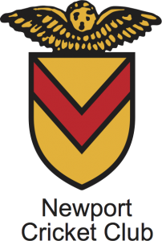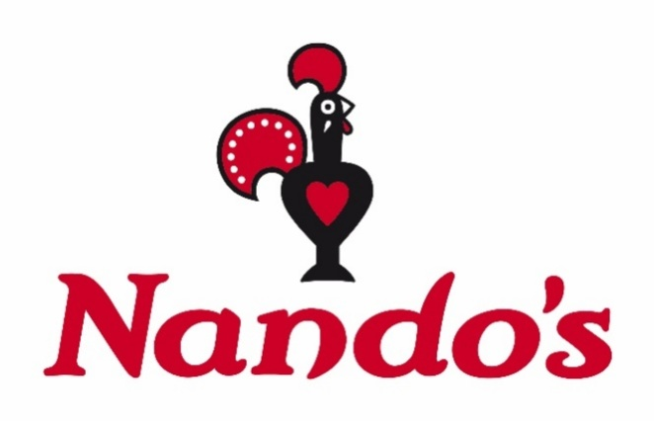

The Barci Blast

Newport Cricket Club XI

V’s

Nando’s XI

Where: Newport Cricket Club

Gates open: 16:45

First ball: 17:00

Ticket price: £5

All proceeds go to charity



In aid of



https://www.justgiving.com/fundraising/Nando-s-Friars-walk-Newport?utm_id=25