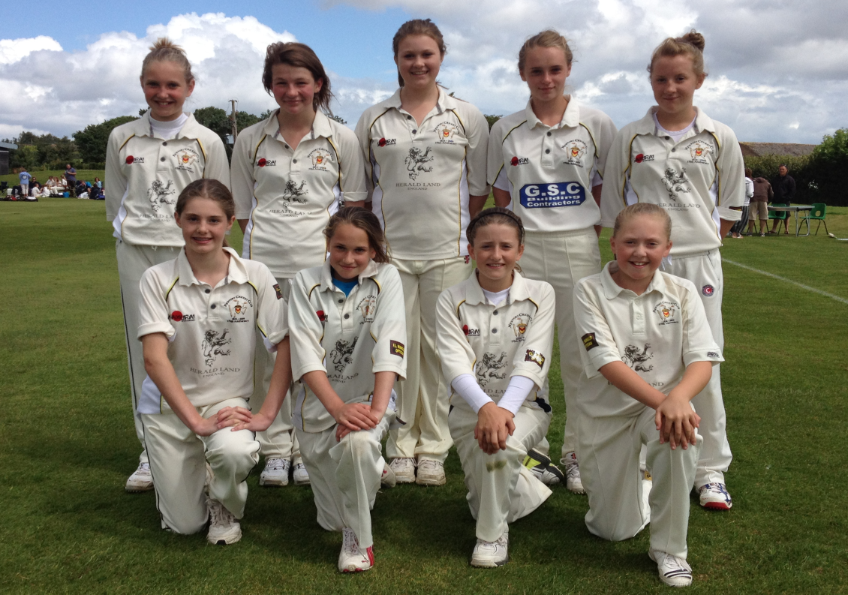

**U13 Lady Taverner’s**

**Welsh Cup Winners 2012**

v Cardiff - Won by 7 wkts

v Whitland - Won by 42 runs

v Lisvane - Won by 5 wkts

 v Neath - Won by 45 runs

**Final Positions**

Banbury (Oxford) **13pts**

Finchampstead (Berks) 13**pts**

**Newport (Wales)**   **13pts**

Taunton (Somerset) **9pts**

Bovey Tracey (Devon) **7pts**

Bristol (Glos.)  **5pts**

**U13 Lady Taverner’s**

**ECB South West Regional**

**Runners Up 2012**

v Banbury (Oxford)

Lost by 13 runs

v Bristol (Glos.)

Won by 23 runs

v Finchampstead (Berks)

Won by 2 runs

v Bovey Tracey (Devon)

Won by 1 run

v Taunton (Somerset)

Won by 29 runs