Newport U13 Gain 2015 League and Cup Double
Newport Cricket Club U13’s gained the League and Cup Double by beating Chepstow in the MBS Final held at Malpas CC. The U13 Final was tipped as a close affair, however on the day Newport proved far to strong for Chepstow, winning by 8 wickets and hence gaining the League and Cup Double over their closest challengers.
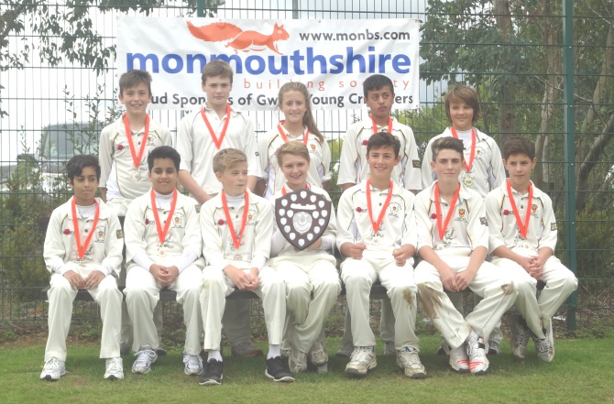

The Victorious Newport U13 MBS Shield Winners 2015

Chepstow batted first and got off to a quick start with 16 runs coming of the first 2 overs. However, at this stage a disasterious run out of Ryan Scrivens, followed by another wicket next ball set the innings back. T.Franklin with 21 and M.Goddard 11 tried to get the innings back on track, but another flurry of wickets saw the score tumble to 54-6 off 12 overs, with Muaaz Shahid claiming 2 quick wickets. Harry Bachelor followed up with another 2 wickets and
the Chepstow innings was in disarray, eventually being bowled all out for just 63. All the bowlers bowled well, with Muaaz Shaid 2-8 and Harry Bachelor 2-0 being the pick.

Captain Nathan Berry and Ben Hope-Bell were determined to get Newport off to a good start, and batted cautiously taking the score to 25 off 7 overs, before Hope-Bell was out. Berry continued to play the captain's role and despite losing another wicket he found a great partner in Morgan Mohring, who played the hard hitting role which was needed. Hitting 4 fours in a quickfire 25no in just 23 balls, he took the game away from Chepstow and with Berry (25no) looking in no trouble at the other end, the two comfortably took the score past the required 64 run target with 8 wickets and 5 overs to spare.
The man of the Match Award was awarded to Newport Captain, Nathan Berry.
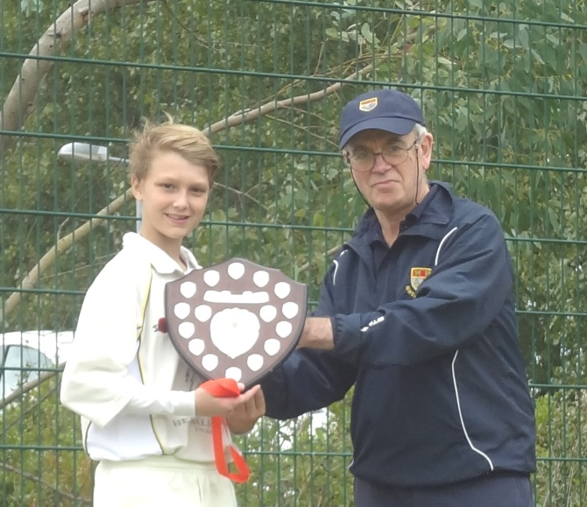

Newport U13 Captain, Nathan Berry Presented with the Man of The Match Award

