Newport U11 MBS League and Cup Double Winners 2015
The U11 Final proved to be the closest and most exciting of the three Finals, with Newport edging past Chepstow, winning by 8 wkts with just 1 ball to spare.
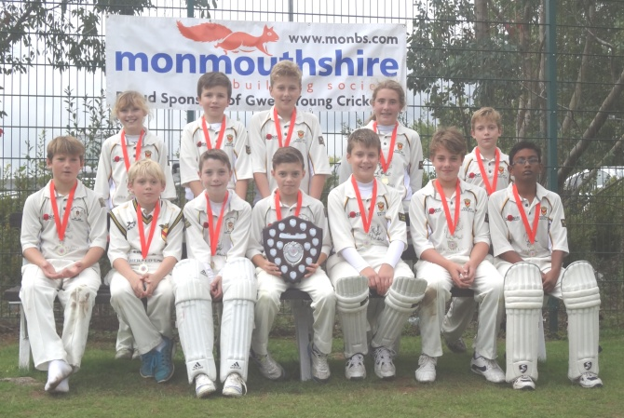

The Victorious Newport U11 MBS Shield Winners 2015

Newport won the toss and put Chepstow into bat, however Chepstow openers Ben Kellaway and Ollie Raynor proved to be a major obstacle in their path. The Chepstow openers batted superbly taking the score to 51-0 off 10overs. Kellaway in particular began to dominate the bowling hitting 8 fours in a fine 74 not out as Chepstow's innings closed on 118-0 off their 20 overs. Raynor himself scoring a useful 28no.

It was a daunting score to chase, but the Newport team is made of stern stuff, not to mention good ability. Openers Sam Protheroe and Harry Hughes, both Welsh Internationals, began cautiously, but upped the run rate to see Newport through to 51-0 off 10 overs, and then upto 77 before the partnership was finally broken in the 15th over, with both Hughes (29) and Protheroe (30) out in consecutive balls.
A good foundation had been laid, but 41 runs were still required off just 5 overs. However, Welsh cap and England triallist, Sophie Thomas along with fellow International Ross Mohring beagn to assert their authourity on the bowlers and with fine running and a few stray wides, Newport were always in the game, but slightly underdogs.
26 runs wree needed off the final 3 overs, which was reduced to 16 off the last 2 overs. An excellent penultimate over resulted in Newport needing just 6 off the final over. A few scampered singles and a wide had everyone on the edge of their seats, with the game being decided on the final ball, with Newport still needing 2 to win. With the adrenalin pumping, players on both sides were under pressure, unfortunately for Chepstow a wide was bowled
and when the Newport batsmen scampered a quick single the game was all over, Newport winning a pulsating game by 8 wickets with just 1 ball to spare. Sophie Thomas 15no and Ross Mohring 16 no being the heroes, while Chepstow will rue the 18 wides bowled throughout the innings. Chepstow's Ben Kellaway, deservedly won the Man of the Match Award for his fine all round display with bat and ball.
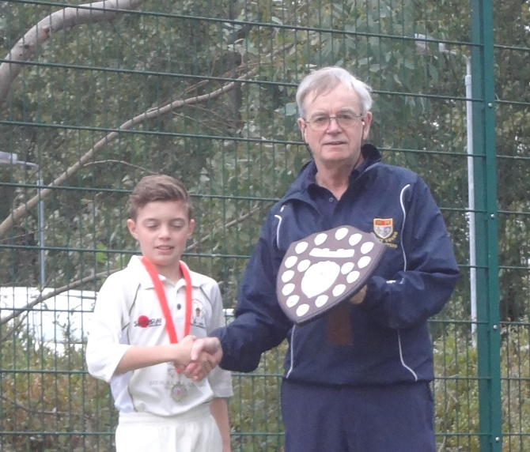

Newport U11 Captain Sam Protheroe Receives the 2015 MBS Shield

