Newport CC U13’s Win Welsh Cup
Newport CC U/13 team celebrated winning the Welsh U13 Cup beating Aberystwyth and Brymbo in a Triangular Finals Day at Builth Wells on Sunday, July 11, 2004.
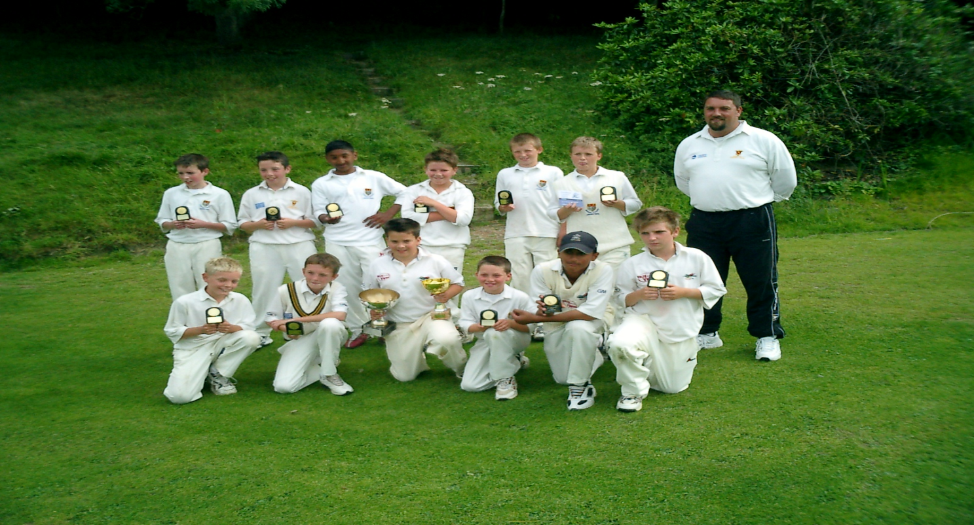

Having previously beaten Abergavenny, Chepstow, Radyr, and Llantwit Major to win the South Wales Zone, Newport progressed to meet Aberystwyth in the first of the Finals Day matches.
Newport v Aberystwyth
Newport won the toss and elected to bat. Welsh U/13 International, and Captain, Tyrone Hoskins, leading by example with a good 28 and Adam Millichip (Welsh U/12 International) with 13 got Newport off to a useful start. With the rules of the competition stating that players have to retire when they score 30, the strength of the whole team is imperative. Imran Hassan (Welsh U/12 International with a good 30 and Najaf Iqbal with 22 made sure Newport posted a good opening score, finishing on 106 - 4 off the allotted 20 overs.Aberystwyth, in reply soon lost an early wicket, but Welsh U13 Squad players G. King and M. Evans set up a tense finish, both retiring on 30 runs. Newport were always just ahead on run rate, and tight bowling backed up by some excellent fielding, which led to three run outs, saw Newport home to a close 9 run victory. Imran Hassan with 1 wicket for just 6 runs off his 4 overs was the pick of the bowlers. With Brymbo beating Aberystwyth in the next game, it meant it was all set up for a winner takes all Final game.
Newport v Brymbo
Newport again chose to bat on winning the toss but got off to a disasterous start losing 2 early wickets. Imran Hassan 33 (retired) and Najaf Iqbal 24 began to gain control and with Josh Aston adding 18 and Lee Watkins 11 not out the Newport total eventually reached an impressive 115 - 4. Brymbo, chasing the highest score of the day, lost early wickets themselves falling to 25 - 3. The introduction of Left Arm Chinaman spin bowler Max Scarr into the attack caused havoc among the remaining Brymbo batsmen and they slumped to 59 all out. Max Scarr finishing with the impressive figures of 5wkts for just 8 runs. Newport winning by 59 runs.
The results meant Newport were crowned Welsh U/13 Cup Winners, the first time for Newport to win the trophy since 1983.
With 8 of the team available to play again next year a lot will be expected!
Team:- Tyrone Hoskins (Capt), Adam Millichip, Imran Hassan, Najaf Iqbal, Josh Aston, Lee Watkins, Max Scarr, Matthew Hazlehurst, Nathan Hardwick, David O'Donovan, Michael Watkins, Jamie Weller.

