Newport CC 175 Anniversary Brochure
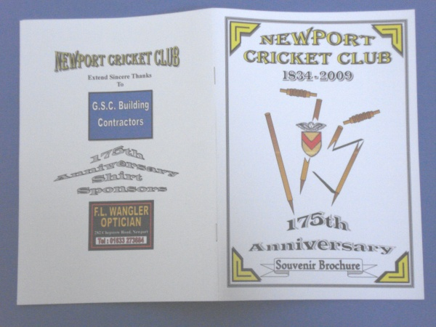
2009 marks Newport Cricket Club's 175th Anniversary. A whole host of events have been organised to celebrate the anniversary, and the club has produced an Anniversary Brochure to mark the occasion. The 40 page brochure is a great read and follows Newport CC's history from the early days of 1834 through to the current time.
Features include:-
- The Early Days at Rodney Parade (Early Newport Professionals - Silverlock, Diver etc)
- The War Years
- Monmouthshire CCC & Glamorgan CCC First Class Cricket in Newport
- Newport Old Boys
- Newport CC's Invincible Seasons
- The 'Famous Grouse Western League
- The National John Haig & William Younger Knockout Competitions.
- Cricketing Legends playing against Newport - W.G Grace, Viv Richards, Allan Border and Shane Warne.The Brochure includes a copy of the signed Scorecard when Shane Warne played against Newport CC in 1989.
- Rodney Parade's 'Most Memorable Match'
- The Final Countdown 'The end of Cricket at Rodney Parade'
- The Ashes Match
- The Development of Spytty Park
- Junior's UK Successes
- Gwalia Welsh Cup Winners 2008
- Newport Legends
As well as Dates / Times etc of the many events, functions and special matches held by the club this year, including details of a special match arranged at Lords. If you can't join us for some of the functions you can support the club by purchasing a copy of the Souvenir Brochure.
The brochure is on sale for £3.50 from the club or alternatively, send a stamped addressed envelope (C5 : 23cm x 16cm)) to:-Dave Knight, 1 Holland Close, Rogerstone, Newport, South Wales. NP10 0AU Cheques made payable to Newport Cricket Club.
A copy of the brochure will be sent by return post. Who knows what the value of the brochure may be worth in years to come. Order your copy now, there is only a limited number of copies available, first come - first served!
A MUST HAVE FOR EVERY SUPPORTER OF NEWPORT CRICKET CLUB AND CRICKET IN GENERAL.

