Size Guide  (inches) | XSB  30’’ | SB  32’’ | MB  34’’ | LB  36’’ | XSM  38’’ | SM  40’’ | M  42’’ | LM  44’’ | XL  46’’ | 2XL  48’’ | 3XL  50’’ | 4XL  52’’ | 5XL  54’’
Price | £31 | £31 | £31 | £36 | £36 | £36 | £36 | £36 | £36 | £36 | £36 | £36 | £36
Quantity
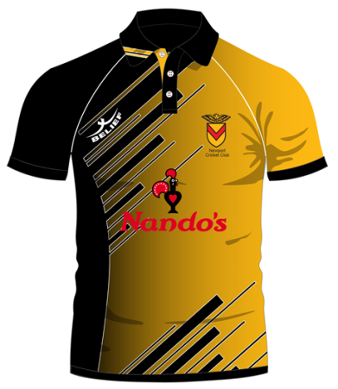
Cheque Enclosed For : _______
Junior Sizes (XSB, SB, MB) Senior Sizes (LB, XSM, SM, M, LM, XL, 2/3/4/5XL)
Sizes are actual shirt sizes, therefore a 36” chest should order a 38” or 40” shirt

Actual Shirt size (inches) | 8Y (MB)  32’’ | 10Y (LB)  34’’ | 12Y (XLB)  36’’ | 14Y (XS)  38’’ | S  40’’ | M  42’’ | L  44’’ | XL  46’’ | 2XL  48’’ | 3XL  50’’
Price | £26 | £26 | £26 | £27 | £27 | £27 | £27 | £27 | £27 | £27
Quantity
All Newport Junior teams will wear coloured clothing for all matches in 2018
Waist Size  Guide (inches) | 10Yr  26-28’’ | 12Y  28-30’’ | 14Y  30-32’’ | S  32-34’’ | M  34-36’’ | L  38-40’’ | XL  42-44’’ | 2XL  44-46’’ | 3XL  46-48’’
Price | £27 | £27 | £27 | £28 | £28 | £28 | £28 | £28 | £28
Quantity
Sizes are actual shirt sizes, therefore a 36” chest should order a 38” or 40” shirt

Actual Shirt size (inches) | 8Y (MB)  32’’ | 10Y (LB)  34’’ | 12Y (XLB)  36’’ | XS  38’’ | S  40’’ | M  42’’ | L  44’’ | XL  46’’ | 2XL  48’’ | 3XL  50’’
Price | £28 | £28 | £28 | £29 | £29 | £29 | £29 | £29 | £29 | £29
Quantity
Very few items will be held in stock, so order now

Size Guide | 8Y  23’’ | 10Y  27’’ | 12Y  31’’ | 14Y  34’’ | S  38’’ | M  42’’ | L  46’’ | XL  48’’ | 2XL  50’’ | 3XL  52’’
Price | £29 | £29 | £29 | £29 | £30 | £30 | £30 | £30 | £30 | £30
Quantity

Size Guide  Chest (cm) | 6Y  84cm | 8Y  89cm | 10Y  96cm | 12Y  101cm | 14Y  102cm | S  102cm | M  104cm | L  110cm | XL  116cm | 2XL  122cm | 3XL  128cm | 4XL  134cm
Price | £22 | £22 | £22 | £22 | £22 | £24 | £24 | £24 | £24 | £24 | £24 | £24
Quantity |  |  |  |  |  |  |  |  |  |  | (This will be the only order for the  2018 season!)

CAPS
(Adjustable size setting)
Price | £12
Quantity
Size Guide | 8Y  24-26’’ | 10Y  26-28’’ | 12Y  28-30’’ | 14Y  30-32’’ | S  32-34’’ | M  34-36’’ | L  36-38’’ | XL  38-40’’ | 2XL  40-42’’ | 3X  42-44’’
Price | £19 | £19 | £19 | £19 | £20 | £20 | £20 | £20 | £20 | £20
Quantity
Please send money with order (payable to Newport Cricket Club) by Wed 29th November.
Name :

Please return Order (with payment) to :- Mike Knight, 1 Holland Close, Rogerstone, Newport, South Wales. NP10 0AU
Junior Sizes (6, 8, 10, 12, 14) Senior Sizes (S, M, L, XL, 2XL, 3XL, 4XL)
(Junior Sizes (8, 10, 12, 14) Senior (S, M, L, XL, 2XL, 3XL)
Junior Sizes (6, 8, 10, 12, 14) Senior Sizes (S, M, L, XL, 2XL, 3XL)

