

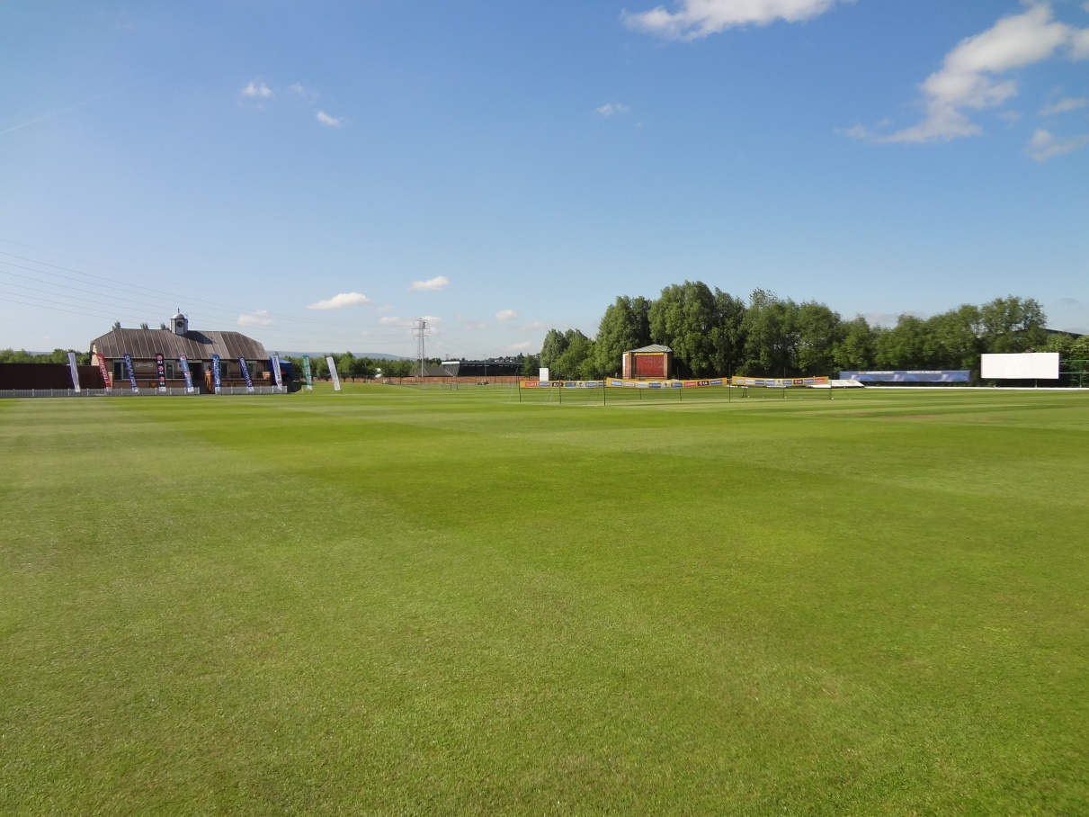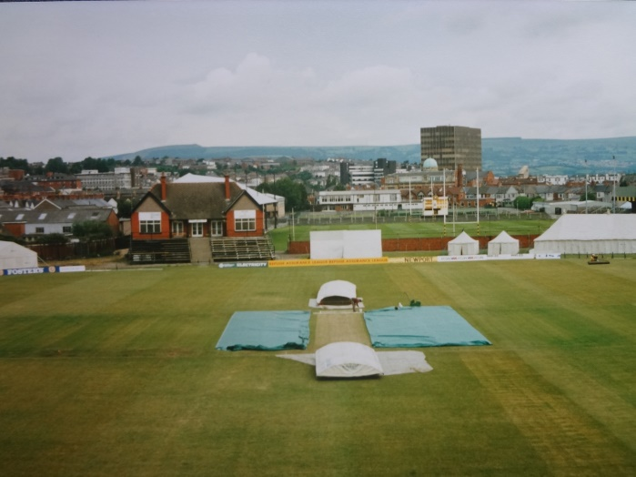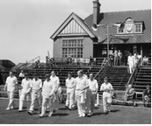

**Benefits – What the Sponsor Gets!**

* Recognition of the Sponsor on the Club website.
* Companyname and logo placed in Match Day Programme.
* Invitation to Newport C.C. Sponsors’ Day (a Premier League Match), with Free Refreshments for you and 2 guests.

**Company Name :**

**________________________**

**Tel No :**

**________________________**

**Website** :

________________________

Sponsorship / Advertising Arrangements

**Please find a cheque enclosed for :**

Cheques payable to ***Newport Cricket Club***

**Return to : Dave Knight**

1 Holland Close, Rogerstone, Newport. NP10 0AU

Tel: 01633 663297 or 07704565912

email : dave.knight@ntlworld.com

Please send pdf file of company logo/advert required to:-

**dave.knight@ntlworld.com**

Top Class (List A) Cricket Returns to Newport

Glamorgan v Pakistan ‘A’

At Spytty Park on Friday, July 15th, 2016

Match Day Programme Advert

Company Advert in Match Day Programme

Advertise your company in the Match Day Programme for the **Glamorgan v Pakistan ‘A’** game.

A large crowd is anticipated and an advert in the Match Day Programme will be the ideal way to promote your company.

Adverts will range from £25 - £100 depending on the size of the Advert.

**Company Acknowledgement £25**

**Half an A5 Page Advert £50**

**Full A5 Page Advert £100**

***Club website: www.newportcricketclub.co.uk***

**Printing Deadline – Sunday, June 5th**