Match Mascot Izzy, Meets Ricky Ponting and Andrew Strauss

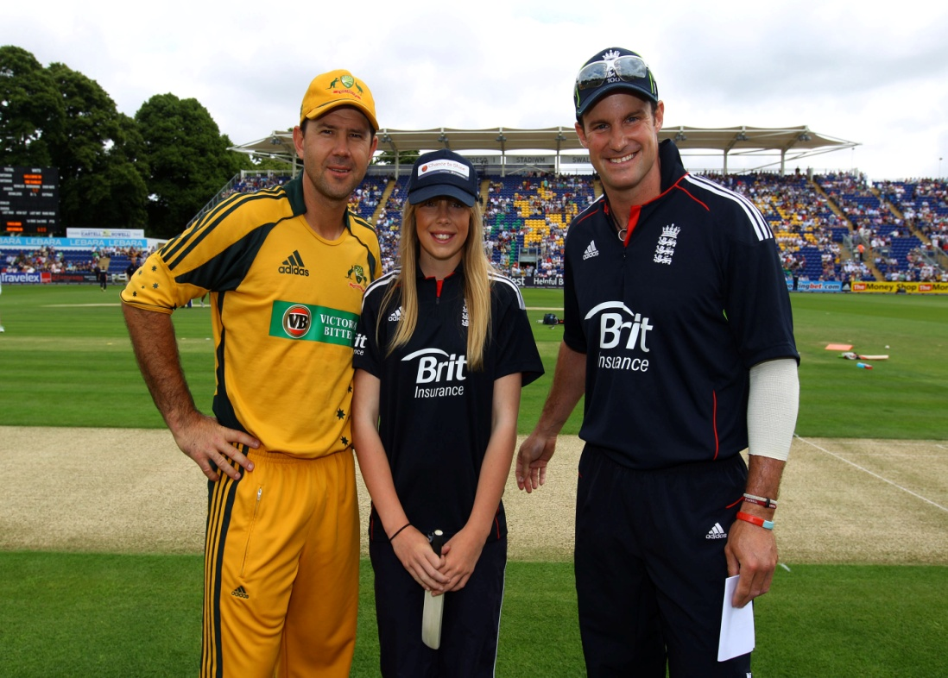

Izzy Berry one of Newport Cricket Club’s highly talented girl cricketers, had the experience of a lifetime when she was chosen as the official Chance2Shine match mascot at the recent England
v Australia One Day Cricket International at SWALEC Stadium in Cardiff.

Izzy, was identified as a cricketer of outstanding potential when Newport Cricket Club’s c2s coaches visited Marshfield School last summer. Twelve months later Izzy, has lived up to expectations and has already been selected to represent the Wales U/13 Girls team. As part of the c2s initiative, Izzy accompanied the captains Andrew Strauss and Ricky Ponting onto the field and witnessed the toss of the coin, all filmed live on Sky Sports TV.

Izzy’s coach at Newport Cricket Club Mike Knight commented :-
‘Izzy had a fantastic day and both Izzy and her parents were looked after very well. Izzy had her photograph taken individually with every England player and they all gave her their autograph, including her favourite player Stuart Broad, who was celebrating his birthday. Izzy said that Andrew Strauss was really nice and that all of the players made her welcome, she even had banter with James Anderson about her Welsh accent’

Any Girls (7 – 16) interested in playing cricket should contact :-
Mike Knight on 01633/663297 or 07793823294 or email : mike.knight2@ntlworld.com

