ECB Under 13 UK 'Spirit of Cricket' National Champions 2005
Newport Cricket Club U/13’s were crowned Under 13 ECB National Champions for 2005, with an emphatic unbeaten seven match run against some of the best club teams in the country at Oakham School. Over 1600 teams entered the 'Spirit of Cricket' U/13 Club Championship, but it was Newport who gallantly came out on top.
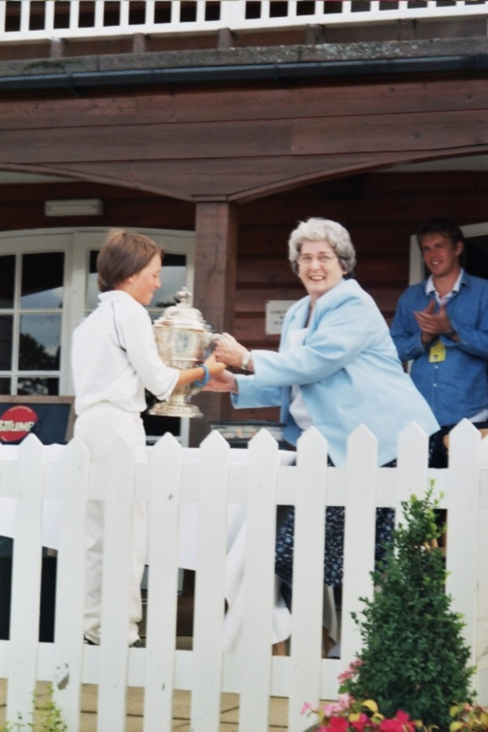
Captain, Max Scarr Receives the 'Ken Barrington' Trophy from Ken's Widow Anne.

Newport Cricket Club were one of eight finalists in the U/13 U.K National Finals held at Oakham Public School. Having previously won the Welsh Cup, they booked their place by beating the Gloucestershire Champions, followed by victory in the West Midland Region, beating opposition from Worcestershire, Herefordshire and Oxfordshire.
Over 1600 hundred teams entered the 'Spirit of Cricket' U/13 Club Championship. The format of the week was to play 20 over matches against the other seven Regional Champions. Two games a day, the Finals were to be played on a League basis.

Regional Winners - Club (County)
West Midland Champions - Newport CC (Wales)
North East and Scotland Champions - South Northumberland CC (Northumberland)
North West Champions - Porthill Park CC (Staffordshire)
Yorkshire Champions - Doncaster Town CC (Yorkshire)
North Midlands Champions - Radcliffe on Trent CC (Nottinghamshire)
South West Champions - Bath CC (Somerset)South
South East Champions - Harrow St. Mary's CC (Middlesex)
East Champions - Ilford CC (Essex)

Day 1

The draw gave Newport a tough start as they had to play Yorkshire champions, Doncaster Town and South West Champions Bath on the first day. In the game against Doncaster, Newport won the toss and elected to bat. A good, accurate Doncaster bowling attack made the Newport batsmen fight for every run and after 10 overs, Newport had only managed 36-3. Lee Watkins took up the challenge, and with a couple of useful partnerships, began to take Newport into a good position. Watkins had to retire on 30, just as the Newport innings closed on 105-7. Doncaster's top order in reply had no answer to the Welsh opening pace attack of Imran Hassan, who claimed 2 early wickets and Najaf Iqbal, and slumped to 15-3wkts. The introduction of left arm spinner and captain Max Scarr, and off spinner Josh Aston caused havoc and Doncaster spirralled to 37-9wkts. Scarr finishing with the impressive figures of 4 wkts for 7 runs, including 3 in his first over. Doncaster were eventually all out for 50, leaving Newport winners by 55runs.
The second game of the day saw Newport play the much fancied Bath team. Newport again won the toss and elected to bat, but suffered an early setback when they lost opener Imran (9), with just 12 runs on the scoreboard. Josh Aston joined Adam Millichip, but runs were proving difficult to come by, on a slow low wicket. After 11 overs Newport had managed just 38-1, but with wickets in hand, they soon began to accelerate. Millichip was out for 15, but then ,the in form, Lee Watkins joined Aston to form a match winning partnership. Boundaries were now becoming common place as Aston retired on 33, and the score on 80-3 off 17 overs. Lee Watkins (25 not out), was well supported by Najaf Iqbal (12), and Max Scarr (11), and after the allotted 20 overs, Newport had reached an impressive 114-4.Any hopes Bath might have had of winning were quickly dispelled as Najaf and Imran ripped through their early batting and they slumped to 18-4 off just 5 overs. When Lee Watkins claimed a further 2 wickets to reduce Bath to 30-6, the game was well and truly going Newport's way. N. Pang (30 retired) tried valiantly to stop the onslaught, and a stubborn 17n.o by E.Robinson (son of former Bath Rugby International, Andy), could not halt the slide and Bath were reduced to 74 all out, leaving Newport impressive winnersby 40 runs. Lee Watkins finishing with fine figures of 4wkts for just 8 runs, and Najaf 3wkts for 15 runs. With 10 points for a win, at the end of the first day Newport sat proudly at the top of the table, with all the other sides having lost at least one game.

Day 2
On day 2, Newport had a real shock in store for them early on, as they lost their first three wickets for just 11 runs, against the pace attack of Radcliffe on Trent, the Nottingham Champions. Things got even worse for them as they slumped to 20-5 off 7 overs. Najaf Iqbal dug deep, scoring a good 18, and with some useful contributions from Yousef Ali (8) and Elgan Alderman (6), and particularly Amier Hussain 13 not out, Newport were eventually bowled out for a respectable 73 runs in the last of their 20 overs. Newport needed an early wicket, and opening bowlers Imran and Najaf did not disappoint. In a fiery 2 over opening burst, they demolished the early Radcliffe batting, claiming 2 wickets apiece as Radcliffe fell to 5 runs for 4 wkts. Najaf in particular was proving unplayable, and despite a minor recovery to 26-4, it was Najaf who completely ripped the heart out of the Radcliffe innings claiming 5 wkts for just 8 runs, as they slumped to 35 all out in just 11 overs, leaving Newport winners by 38 runs. Josh Aston with 2 wickets for 1 run and Imran 2 wickets for 20 runs completed the rout.
Next game up was against the Essex Champions, Ilford. Newport again batted first, but with the wickets proving very slow and bowler friendly, runs again proved hard to come by. Newport got off to a dreadful start falling to 10 runs for 3 wickets off the first 5 overs. Lee Watkins (16) and Max Scarr (16) stopped the rot, taking the score to 44 off 13 overs. But when they both departed in successive overs, along with a further run out, Newport had slipped to 47-6 wkts. Yousef Ali and Amier Hussain battled back and in an unbroken stand of 37 took Newport to a healthier 84-6 off their allotted 20 overs. Yousef finishing on 14n.o and Amier on 16 n.o. A big effort was again required from the Newport bowlers, but despite gaining an early wicket on 8, the Ilford batsmen were just content to see out the Newport opening attack, and when spin was introduced they were on 20-1 off 6 overs. Then, 2 wickets fell with the score on 22 both to off spinner Josh Aston. However, it was left arm spinner Max Scarr who was beginning to bowl a devastating spell. From 46-3 off 12 overs, Scarr tied the Ilford batsmen in knots, claiming the next 6 wickets in just 3 overs, which also included a hat-trick, and Ilford had slumped to 57-9. The last pair took the score to 63 when their allotted 20 overs finished, but thanks to Scarr 6 wkts for 16 runs, Newport had won their fourth consecutive match.
With 10 points for a win Newport were top of the 8 Team League on 40 points, with Bath their nearest challengers on 30 points.

Day 3
The first game on Day 3 was against one of the weaker teams, South Northumberland. Newport again won the toss and elected to bat first. Adam Millichip was the man in form as he scored a good 28, while Imran with 13 gave good support. With the score on 53-2 off 9 overs, Newport had got off to the start they wanted. Lee Watkins was joined by Najaf Iqbal and the two shared a 51 run stand together. Watkins finishing with 21 not out and Najaf retiring on 30. A final flurry of runs and wickets took the Newport total to a good 115-4 off their 20 overs.The score was always likely to be a formidable one for South Northumberland, but Najaf and Imran put the game completely beyond them, as they struck with a devastating opening burst, claiming 3 wickets each to reduce them to a meagre 14-6 off their initial opening burst. J. Harbottle offered good resistance scoring 28 not out, but at the end of the 20 overs, they could only manage a miserly 63 for 7 wickets. Imran with 3wkts for 5 runs and Najaf 3 wkts for 6 runs being the star performers.
In their second game of the day, Newport faced the Staffordshire Champions Porthill Park, who were in 3rd place at the start of the day. Porthill won the toss and put Newport in to bat. The opening partnership of Imran and Adam Millichip got Newport off to a good start, scoring 35 for the first wicket in just 6 overs, before Millichip was out for 15. Imran continued to score freely and with Josh Aston (19n.o) they took the score to 75-2 before Imran had to retire on 32. A slow spell in the middle of the innings was put right by Najaf, who came in in the 16th over and smashed 23 in just 16 balls, taking the final Newport score to a healthier looking 104-3.The Staffordshire side were renowned for some big hitters and were always going to be a serious threat. However, they were set back on their heels as Imran and Najaf continued their ruthless streak, claiming the first 5 wickets to fall between them, as Porthill slumped to 19-5 off just 5 overs. Any chances of an easy victory were soon dismissed as A.Naeem struck a quick 30 and had to retire. Lee Watkins clean bowled a further two Porthill batsmen, and with left arm spinner Max Scarr claiming another wicket, the last pair of Porthill batsmen were at the wicket with the score on 63-9. With 42 needed to win, Newport felt they were home and dry, but the tailenders were proving difficult to shift. With 4 overs remaining, the two batsmen slowly but effectively took the score to 90-9. Needing just 15 to win now, things were beginning to look bleak. However, Newport's hard work and team play paid off, when the last Porthill batsman smashed a full toss, towards the deep square leg boundary. With the ball hit full force low and hard, Najaf, on the boundary took a magnificent catch (Catch of the Tournament), running 5 metres to his right and clutching the ball one handed down by his calf. A magnificent, match winning catch to see Newport victors by just 14 runs. Imran 3 wkts for 17 runs, Najaf 2 wkts for 13 runs (and his catch), along with Lee Watkins 2 wkts for 9 runs were the pick of the Newport bowlers.
Having won six games out of six (60points), Newport go into the last game against lowly Harrow, knowing that a win will be enough to see them U.K National Champions. Bath however, with 5 wins (50 points) will be hoping that Newport slip up.

Day 4
Day 4 began with heavy overnight rain persisting into the early morning. However, with the squares covered, as soon as the rain stopped, the ground staff were out working with their fantastic equipment to make play possible just 5 minutes late. Harrow won the toss and put Newport into bat. A few nervous jitters were evident early on, but it was not long before the Newport openers Adam Millichip and Imran were looking in total control. Both openers began to play with more freedom as they posted 51 in just 9 overs, and were soon having to both retire with their scores on 31. 27 runs were scored in the next 7 overs, before Najaf (21n.o) joined Lee Watkins (15n.o) in an important final flurry, which took the Newport score upto 113-1 off their 20 overs.
Harrow in reply, suffered the loss of an early wicket when Najaf again took a stunning one handed catch, this time off his own bowling, when the Harrow opener drove him back over his head. Imran, at the other end claimed another 2 wickets, as the Harrow reply faltered on 6-3 off 4 overs. Rearguard action was the call of the day for the rest of the innings and despite one or two lusty blows Newport always had the game in total control. Josh Aston with 3 wkts for 2 runs, and James Baker with 2 wkts for 10 runs, restricted Harrow to a final total of just 63 runs, leaving Newport winners by 50 runs and worthy U/13 National Champions.
Roger Knight, the former England batsman, praised the young Newport team for their unbeaten week's perfomances, before handing over to Ann Barrington, widow of former Test cricketer Ken, to present medals and the Ken Barrington Cup to Newport CC captain Max Scarr, as Winners of the MCC 'Spirit of Cricket' U/13 National Club Championship. A fantastic achievement.
Individual and team pictures were taken with the Ken Barrington Cup, before it was returned to the Vaults of Lords, as it is so valuable. Newport receive a replica to keep.

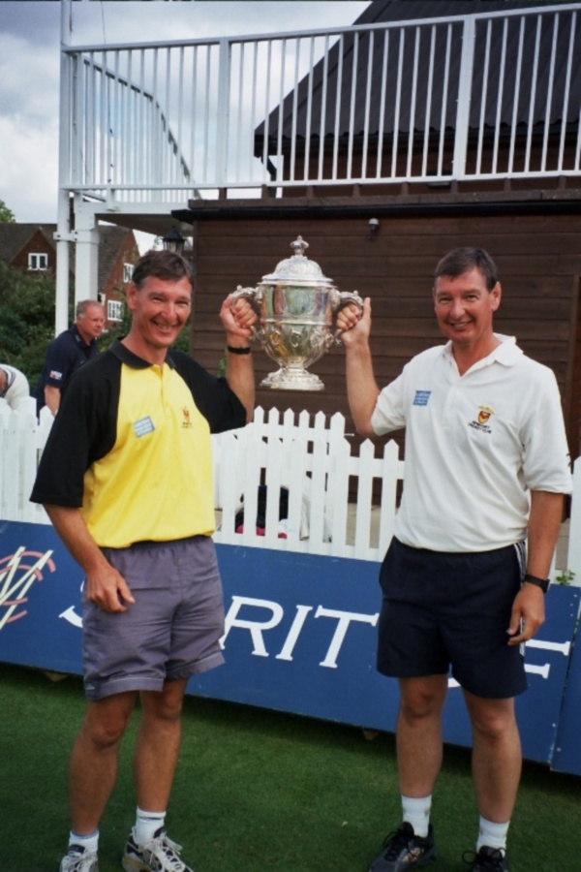

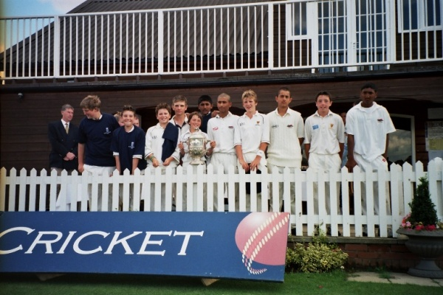
Under 13 UK 'Spirit of Cricket' National Champions 2005

Official Presentation at the SWALEC - Live on Sky TV
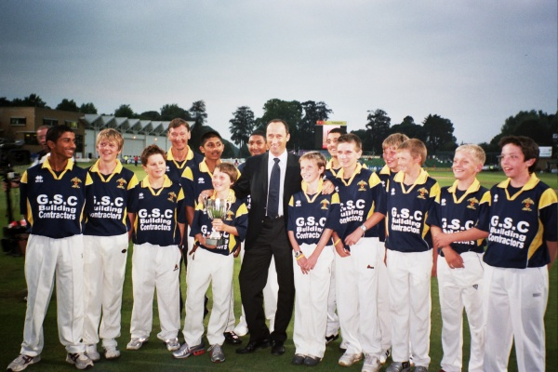
Nasser Hussain Presents the UK 'Spirit of Cricket'
U13 National Championship Trophy. Coaches, Mike and dave Knight with the Trophy
Newport Cricket Club U/13 team enjoyed a tremendous end of season night out, when they were invited to watch the Glamorgan CCC v Hampshire CCC Totesport Trophy match at Sophia Gardens. During the interval between innings they were presented with the U.K 'Spirit of Cricket' National Championship Trophy by former England Captain, Nasser Hussain. With the Glamorgan match being broadcast live on Sky T.V, the young players revelled in the spotlight, as they took centre stage.The team had enjoyed a tremendous unbeaten year having won:-The Gwent Monmouthshire Building Society U/13 League. The Gwent Monmouthshire Building Society U/13 Shield. The Welsh Cup. U.K 'Spirit of Cricket' National Championship.The National Championship obviously being the highlight of the season, where Newport beat all seven Regional Champions in a Finals Week at Oakham School in August. One of the teams Newport beat in the finals were Ilford CC, Nasser Hussain's former club (which he was quick to point out). Having been presented with the Trophy, the youngsters set off on a lap of honour which was warmly greeted by the sporting Glamorgan crowd.
Newport CC - Under 13 UK 'Spirit of Cricket' National Champions 2005

