Newport Cricket Club - Champions Trophy Winners 2009

Newport Cricket Club ended their historic 175th Anniversary season with the news that the club had won the prestigious South Wales League, ‘Champions Trophy’.

The competition, based on the Australian model, recognizes achievement and depth of talent throughout a club, with Senior and Junior playing performances analysed, as well as the club’s playing facilities. In the four seasons of the Award being made, Newport have never been out of the top two, last winning the trophy in 2007.

All the club’s teams performed admirably in 2009:-

Achievements
Senior Teams
1st X1 – Thomas Carroll, S.E Wales Premier League Runners Up.
Qualification to the newly formed South Wales Premier League.
Gwent Macey Cup Winners.
2nd X1 – Thomas Carroll, S.E Wales Premier Reserve League Winners.
3rd X1 – 4th place in Div.3 of the Conference, just missing out on promotion.
4th X1 – Mid table respectability, with a very young side.

Junior Teams
U/11’s - Gwent Mon. Building Society Cup Winners
Gwent League Runners Up
U/13’s - Welsh Cup Winners
UK Midlands Regional Finalists
Gwent (Mon. Building Society) Cup Runners Up
U/15’s - Gwent League Winners
Gwent Mon. Building Society Cup Runners Up
U/17’s - Monmouthshire League/Cup Winners

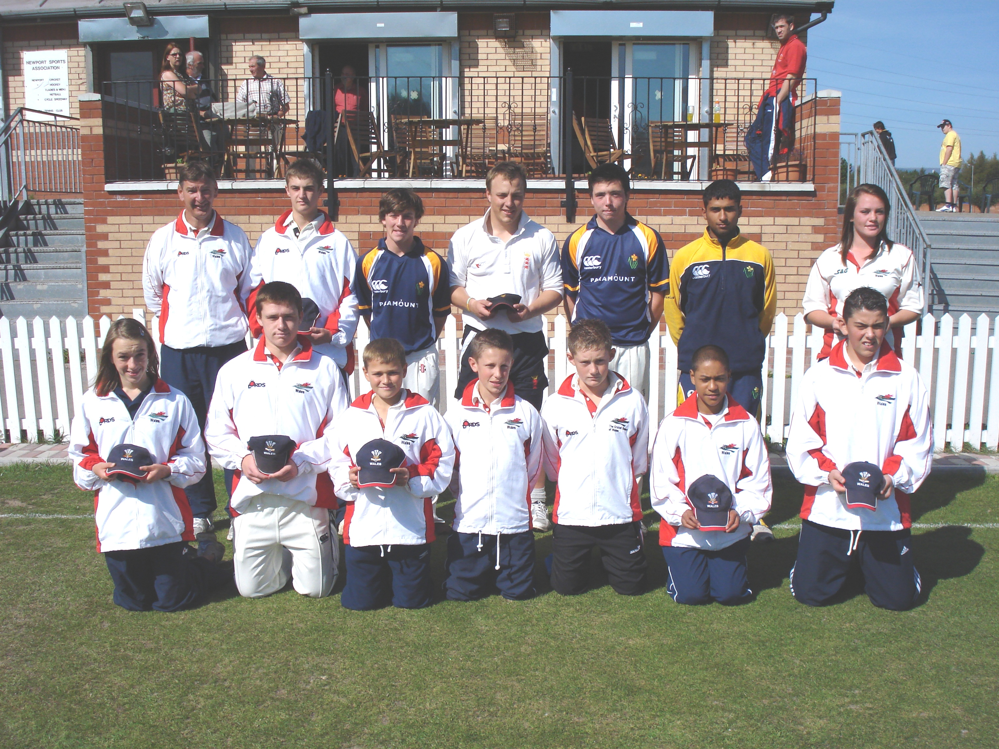
Newport's strong commitment to coaching its Junior players, has always figured prominently and this season was no exception, with the Club producing a number of county players and Welsh Internationals.
The full list of Welsh Internationals includes:-
Senior Welsh International - Michael Clayden Senior Welsh Ladies International - Naomi Williams-Wadley Glamorgan Academy Players - Imran Hassan & Max Scarr Glamorgan U/17 Players - Imran Hassan, Max Scarr & Josh Aston Wales U17 Ladies International - Naomi Williams-Wadley Wales U16 International – Rhydian Knox Wales U14 International – Harry Powell Wales U13 International – Ryan Cobb 2009 Welsh Internationals Wales U13 Girl’s International – Ffion Wynne Wales U12 Internationals – Matty Jones, Luke Harris & Jack Thorpe-Yon Wales U11 International – Darnell Taylor-Wood Welsh U13 Coach - Martyn Strange Welsh U12 Coach - Mike Knight

Club Head Coach, Mike Knight enthused,
‘2009 was always going to be a momentous season with the club celebrating its 175th Anniversary. With all the off the field activities going on, it would have been easy to take our eyes off the playing side. Fortunately the playing side of the club could hardly have been better and Winning the Champion Trophy, for the club with the most successful infra-structure is a real feather in the cap for the club, and reflects on the tremendous efforts of club officials, captains, coaches and players. The club has enjoyed an illustrious past, but can now look forward to a very exciting future’

